**NAME :** D. PAVISHNA

**DEPARTMENT :**  INDUSTRIAL BIOTECHNOLOGY

**COLLEGE :** GOVERNMENTCOLLEGE OF TECHNOLOGY

**NAAN MUDHALVAN COURSE :** DIGITAL MARKETING

**NAAN MUDHALVAN ID :** 5D89F5541A63D7E81B444D398AA16D7C

**ASSIGNMENT ON DIGITAL MARKETING**

1. Create a blog or website using blogspot and wordpress. Coustomize the theme design and post new article with 500 words

Wordpress:

<https://mywindin.wordpress.com/2023/10/30/education/>

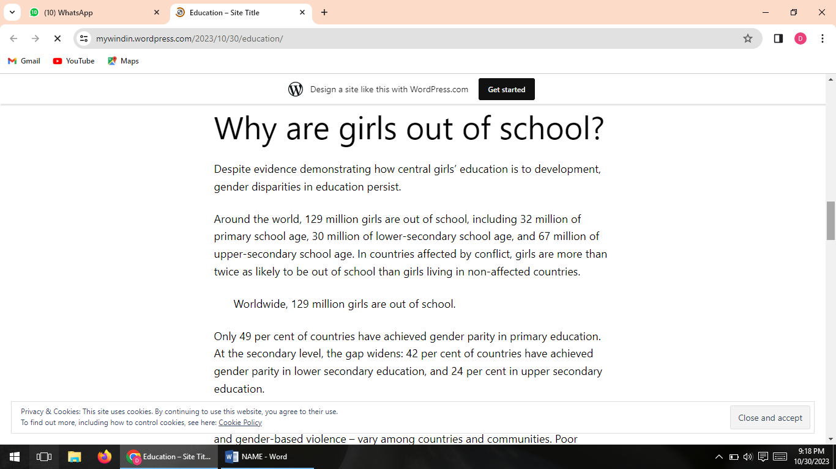

1. Create a new facebook business page and post one social media poster for your brand

Facebook page link

<https://www.facebook.com/profile.php?id=61552620585055&is_tour_dismissed=true>

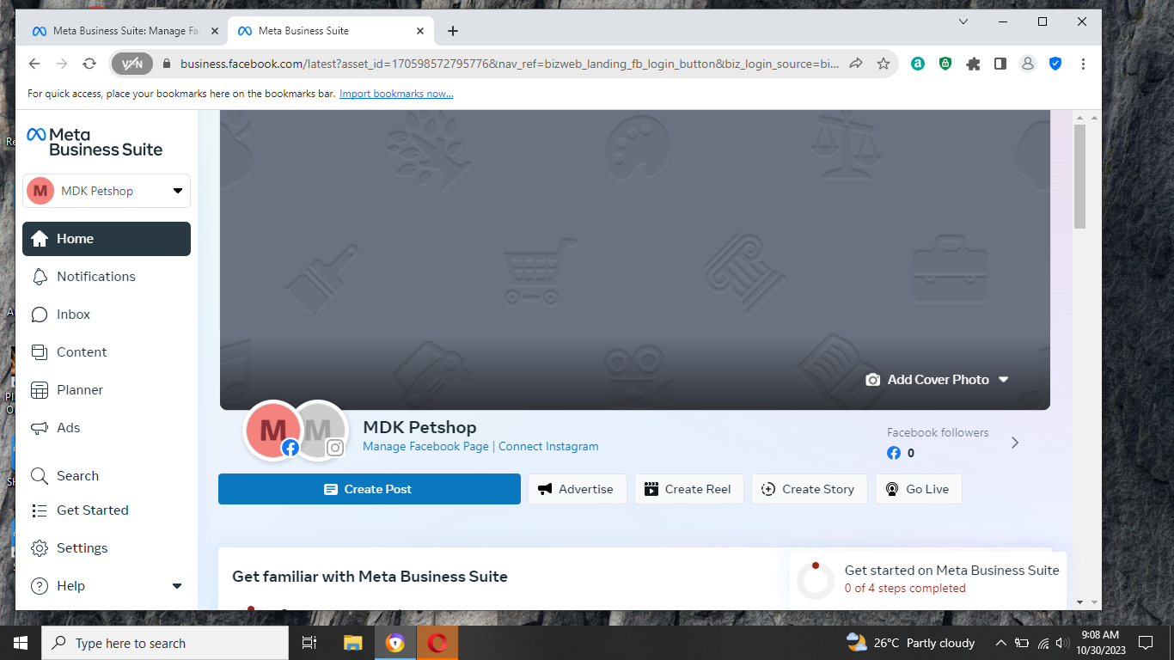

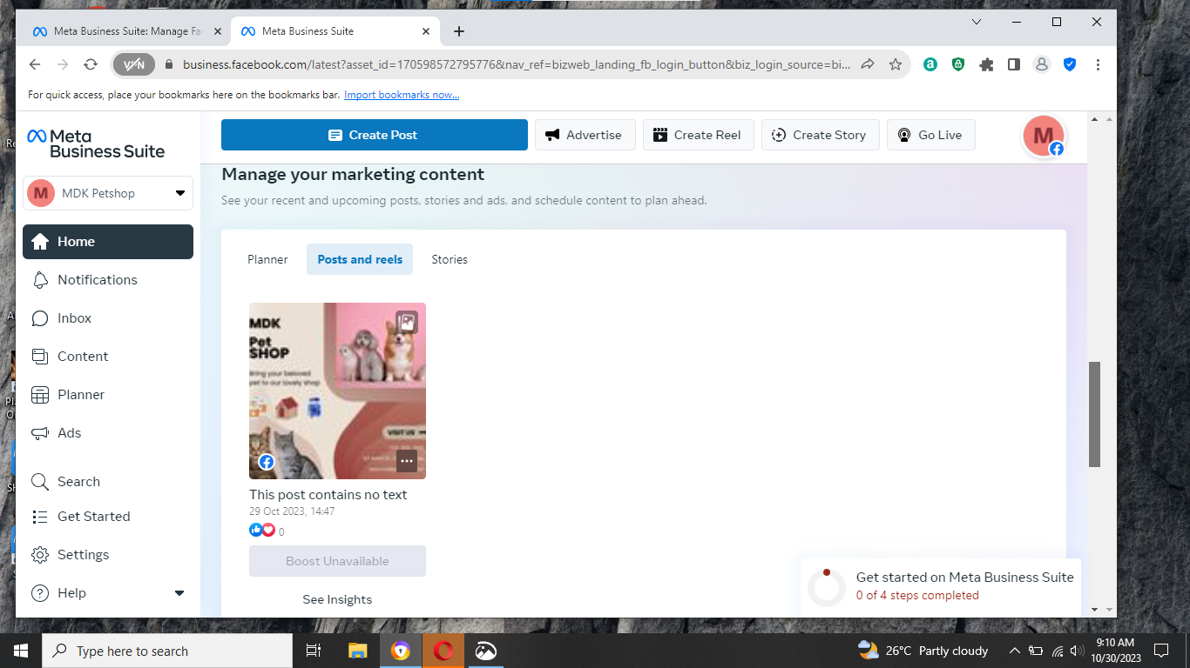

1. Create and design a social media advertisement poster using canva

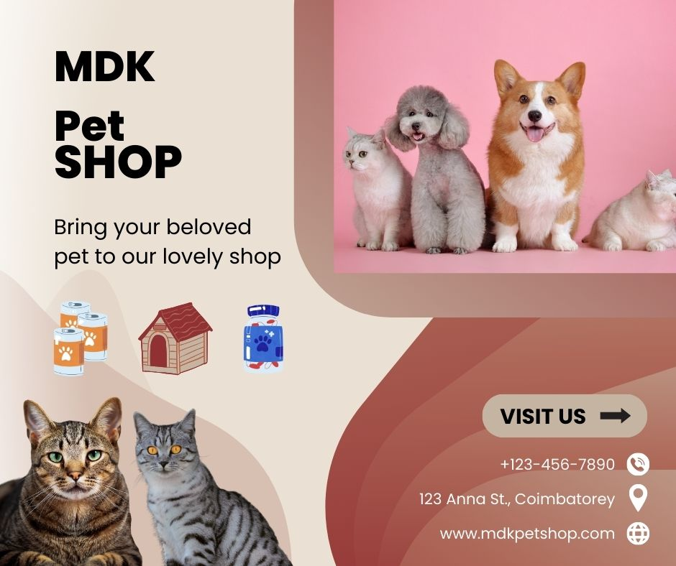

1. Create Email newsletter design using Mailchimp or canva tool

